

A

Report On

**Electric Vehicle Population Database Analysis**

For Subject

**Visual Analytics**

Submitted to

Dr. Saurav Verma

Submitted By

Pragati Bist I033

Riya Singh I041

Shreyaa Nadar I043

**Table of Contents**

**1 Introduction1**

1.1 Overview of Electric Vehicle Market1

1.2 Role of Visual Analytics in Understanding EV Adoption 1

1.3 Objectives of the Electric Vehicle Population Analysis 2

1.4 Scope of the Study 2

**2. Dataset Description4**

2.1 Dataset Overview 4

2.2 Description of Columns 4

2.3 Calculated Fields5

2.3 Data Source and Integrity 6

2.4 Key Variables for Analysis 6

**3. Data Preprocessing8**

3.1 Data Preprocessing Steps Performed8

3.2 Code Explanation8

**4. Visualizations13**

4.1 Part A13

4.2 Part B17

4.2 Part C22

**5. Dashboard & Insights24**

5.1 Dashboard 124

5.2 Dashboard 225

5.3 Dashboard 326

**6. Summary27**

**Reference28**

1. **INTRODUCTION**

**1.1 Introduction to Electric Vehicle Population Database Analysis**

The increasing awareness of climate change, environmental degradation, and the depletion of fossil fuel reserves has brought about a significant shift in the automotive industry. Governments, industries, and consumers are now more inclined toward sustainable and eco-friendly alternatives. Among the most prominent innovations in this shift is the transition from traditional gasoline-powered vehicles to electric vehicles (EVs).[1] Electric vehicles are recognized not only for their reduced environmental impact but also for their potential to revolutionize the global transportation system. They offer a pathway to reducing carbon emissions, decreasing reliance on fossil fuels, and mitigating air pollution, particularly in urban areas.

However, the adoption of electric vehicles is not uniform across regions and consumer segments, nor is it consistent across different manufacturers. With the increasing availability of electric vehicles and the evolution of the market, understanding the dynamics of this emerging trend is critical [1]. A comprehensive analysis of the electric vehicle population can provide insights into the manufacturers dominating the market, regional adoption rates, variations in pricing and range, and forecasted growth.

**1.2 Importance of Visual Analytics in Electric Vehicle Analysis**

In today’s data-driven world, the ability to extract meaningful insights from complex datasets is essential for effective decision-making. Traditional methods of analysing raw data can be time-consuming and may not reveal underlying patterns or trends. This is where visual analytics comes into play. Visual analytics combines the power of data analysis with interactive visualizations, allowing users to explore and interpret data more efficiently.

When analysing the electric vehicle population, visual analytics becomes especially crucial. The electric vehicle market is characterized by a vast amount of data, including variables such as manufacturer production numbers, vehicle types, pricing, electric range, regional adoption rates, and eligibility for clean alternative fuel vehicle (CAFV) incentives [1]. By transforming these datasets into interactive visualizations, decision-makers can gain quick insights, spot trends, and make informed decisions more effectively.

The importance of visual analytics in this context includes:

1. Simplifying complex data: With large datasets like the electric vehicle population, visual analytics helps simplify complexity. By converting thousands of data points into charts, graphs, and maps, it becomes easier to comprehend information at a glance.
2. Interactive exploration: Users can interact with visualizations by filtering, zooming, and highlighting specific aspects of the data, such as focusing on specific manufacturers, regions, or vehicle types. This interaction allows for a more tailored analysis based on specific objectives.
3. Trend identification: Visual analytics facilitates the identification of patterns and trends that may not be immediately apparent in tabular data. For instance, users can quickly observe spikes in electric vehicle production, geographic hotspots for adoption, or changes in consumer preferences over time [1].
4. Decision support: Visual analytics not only provides insights but also supports real-time decision-making. As manufacturers aim to expand their electric vehicle portfolios and governments seek to promote cleaner transportation options, having data visualized effectively helps in making quicker and more strategic decisions.

Through the use of Tableau, our project applies visual analytics to the electric vehicle population database to uncover trends, identify key drivers of growth, and predict future outcomes. These tools enable the development of dashboards, and stories that provide a comprehensive view of the electric vehicle landscape.

**1.3 Objective of the Electric Vehicle Population Analysis**

The primary objective of this analysis is to explore the electric vehicle population and interpret key trends that can guide both strategic planning and operational decision-making. The specific objectives of the analysis include:

1. Understanding manufacturer dominance: Which manufacturers are leading in electric vehicle production, and how has their production evolved over time? By comparing historical and recent production data, we can determine the major players in the market and how their growth aligns with industry trends [1].
2. Examining the impact of vehicle price and range: What are the relationships between the price of electric vehicles, their electric range, and consumer demand?[1] This analysis seeks to segment the market into clusters based on price and range, helping manufacturers understand which segments are the most competitive.
3. Analyzing regional adoption patterns: Which regions or cities are at the forefront of electric vehicle adoption, and what factors contribute to higher adoption rates? By mapping adoption rates geographically, the study will help identify regions that could benefit from increased investment in electric vehicle infrastructure.
4. Forecasting future trends: Using historical data to forecast future electric vehicle production and market growth is another objective of the study. Predictive models will be employed to estimate future vehicle production [1], helping manufacturers and policymakers prepare for potential shifts in demand and supply.

**1.4 Scope of the Study**

The scope of this analysis encompasses several key dimensions of the electric vehicle population, from understanding market dynamics to identifying adoption patterns. Below are the primary focus areas of the study:

1. Manufacturer trends: The study focuses on identifying which manufacturers are producing the most electric vehicles and how this production has evolved over time. Both Battery Electric Vehicles (BEVs) and Plug-in Hybrid Electric Vehicles (PHEVs) will be analyzed to understand how different types of electric vehicles are performing in the market [1].
2. Clustering and segmentation: One of the key features of this analysis is the use of clustering techniques to group electric vehicles based on their price and electric range. By clustering vehicles into categories, the study will reveal market segments such as budget vehicles with shorter ranges, mid-range vehicles, and premium vehicles with extended ranges [1].
3. Geographic analysis: Another focus area is the geographic adoption of electric vehicles. By analyzing where electric vehicles are most popular, the study will provide insights into the role of infrastructure, government incentives, and consumer preferences in driving regional adoption rates [1].
4. CAFV eligibility: The analysis will explore which vehicles qualify for Clean Alternative Fuel Vehicle (CAFV) incentives and how eligibility is distributed across manufacturers. This will help determine which manufacturers and vehicle types are leading the charge in producing environmentally-friendly vehicles that align with government incentives [1[.
5. Forecasting and future trends: Finally, the study will employ forecasting techniques to estimate future production and market trends. By predicting how electric vehicle production will evolve in the coming years, manufacturers and policymakers can plan accordingly for shifts in supply and demand.

**2. Dataset Description**

**2.1 Dataset Overview**

The dataset used for this analysis was sourced from the Electric Vehicle Population Data available on the U.S. government’s open data platform, Data.gov. This dataset has 6000 rows and 12 column. This dataset provides a detailed overview of electric vehicles (EVs) registered in specific regions, including information about the vehicle make, model, electric range, pricing, and geographic distribution. With the shift towards greener and more sustainable transportation, this dataset is crucial for understanding the growing presence of electric vehicles in various counties and cities.

The data provides insights into key factors influencing electric vehicle adoption, such as eligibility for Clean Alternative Fuel Vehicle (CAFV) incentives, electric range, and base price. It also captures the geographic distribution of electric vehicles, allowing for analysis of regional trends in electric vehicle adoption and the infrastructure that supports them.

The dataset comprises several key attributes related to the electric vehicle population and includes both Battery Electric Vehicles (BEVs) and Plug-in Hybrid Electric Vehicles (PHEVs).

**2.2 Description of Columns**

Table 1. Description of Columns

|  |  |  |  |
| --- | --- | --- | --- |
| **Sr.No.** | **Column Name** | **Description** | **Data Type** |
| 1 | County | This is the geographic region of a state that a vehicle's owner is listed to reside within. Vehicles registered in Washington state may be located in other states. | text |
| 2 | City | The city in which the registered owner resides. | text |
| 3 | State | This is the geographic region of the country associated with the record. These addresses may be located in other states. | text |
| 4 | Postal Code | The 5 digit zip code in which the registered owner resides | text |
| 5 | Model Year | The model year of the vehicle. | text |
| 6 | Make | The manufacturer of the vehicle. | text |
| 7 | Model | The model of the vehicle, determined. | text |
| 8 | Electric Vehicle Type | This distinguishes the vehicle as all electric or a plug-in hybrid. | text |
| 9 | CAFV Eligibility | This categorizes vehicle as Clean Alternative Fuel Vehicles (CAFVs) based on the fuel requirement and electric-only range requirement in House Bill 2042 as passed in the 2019 legislative session. | text |
| 10 | Electric Range | Describes how far a vehicle can travel purely on its electric charge. | number |
| 11 | Legislative District | The specific section of Washington State that the vehicle's owner resides in, as represented in the state legislature. | text |
| 12 | Electric Utility | This is the electric power retail service territory serving the address of the registered vehicle. All ownership types for areas in Washington are included: federal, investor owned, municipal, political subdivision, and cooperative. | text |

**2.3 Calculated Fields**

**1. Vehicle Age**:

* Vehicle age plays an important role in understanding the lifecycle, performance, and maintenance needs of electric vehicles (EVs). As EVs age, they may experience reduced battery efficiency, shorter range, and higher maintenance demands, impacting both ownership costs and utility management. Tracking the average age of EVs provides insight into market trends, including vehicle longevity and potential upgrade cycles.

**Formula Used:** 2024-[Model Year]

**2. Age Group:**

* Dividing EVs into age groups, like 0–5, 6–10, and 11+ years, enables a closer look at usage and performance trends. Newer EVs often have better technology and range, reducing their reliance on charging stations, while older EVs may require more frequent charging. Analysing these groups supports infrastructure planning, market assessment, and future energy needs.

**Formula Used:** IF [Vehicle Age] >= 0 AND [Vehicle Age] <= 5 THEN "0–5 years"

ELSEIF [Vehicle Age] >= 6 AND [Vehicle Age] <= 10 THEN "6–10 years"

ELSEIF [Vehicle Age] >= 11 AND [Vehicle Age] <= 15 THEN "11–15 years"

END

**2.3 Data Source and Reliability**

The dataset was obtained from Data.gov, a trusted platform that hosts open data from U.S. government agencies and other public entities. This particular dataset on Electric Vehicle Population is regularly updated by local governments, ensuring that the information is both timely and accurate. As it is sourced from vehicle registration records, the dataset provides a highly reliable picture of the electric vehicle landscape within specific regions.

Site Link: <https://catalog.data.gov/dataset/electric-vehicle-population-data>

**2.4 Key Variables for Analysis**

1. **Base MSRP**:
   * The vehicle’s price before incentives. Analysing the pricing of electric vehicles helps to segment the market and understand the affordability of different models.
2. **Electric Range**:
   * The vehicle’s maximum range on electric power. This is a key factor for consumer decision-making, particularly in regions where charging infrastructure is less developed.
3. **Electric Vehicle Type**:
   * Differentiating between **Battery Electric Vehicles (BEVs)** and **Plug-in Hybrid Electric Vehicles (PHEVs)** allows for an analysis of consumer preferences and the market’s tilt towards fully electric vehicles versus hybrids.
4. **CAFV Eligibility**:
   * Vehicles that qualify for **Clean Alternative Fuel Vehicle (CAFV)** incentives are often more attractive to buyers. Analysing this column helps understand the role of financial incentives in driving electric vehicle adoption.
5. **Geographic Data (City)**:
   * Geographic information provides insights into regional adoption patterns and helps policymakers and infrastructure developers focus on areas with higher EV penetration.
6. **Electric Utility:**
   * This is the electric power retail service territory serving the address of the registered vehicle. All ownership types for areas in Washington are included: federal, investor owned, municipal, political subdivision, and cooperative.
7. **Vehicle Age and Age Groups**:
   * Vehicle age is a key factor in understanding the lifecycle, performance, and maintenance needs of electric vehicles (EVs). As EVs age, they often face reduced battery efficiency, shorter range, and increased maintenance demands, which affect ownership costs and utility management. Dividing EVs into age groups—such as 0–5, 6–10, and 11+ years—reveals trends in usage and performance. Newer EVs generally have superior technology and range, requiring fewer charging stops, while older models may need more frequent charging. Analyzing these groups aids infrastructure planning, market insights.

**3. Data Preprocessing**

**3.1 Data Preprocessing Steps Performed**

To prepare the dataset for analysis, several preprocessing steps were performed:

1. **Handling Missing Values**:
   * Missing data for **Base MSRP** and **Electric Range** were addressed by imputing average values for records with missing fields. In some cases, rows with extensive missing information were excluded from the analysis.
2. **Removing Irrelevant Columns**:
   * Columns such as **State** were removed from the dataset because it pertained only to vehicles registered in Washington state, and the state column did not add any value to the analysis.
3. **Addressing Outliers**:
   * Outliers in terms of **Base MSRP** and **Electric Range** were reviewed. Unusually low or high values were either corrected or removed to ensure the integrity of the analysis.
4. **Filtering Non-Electric Vehicles**:
   * The dataset was filtered to ensure only electric vehicles were included, ensuring that non-electric vehicles or incorrectly tagged entries were excluded.

**3.2 Code Explanation**

**Code:**

import pandas as pd

from sklearn.preprocessing import MinMaxScaler

file_path = '/mnt/data/Electric_Vehicle_Population_Data.csv'

ev_data = pd.read_csv(file_path)

**# Step 1: Check for missing values**

missing_values = ev_data.isnull().sum()

print("Missing values in each column:\n", missing_values)

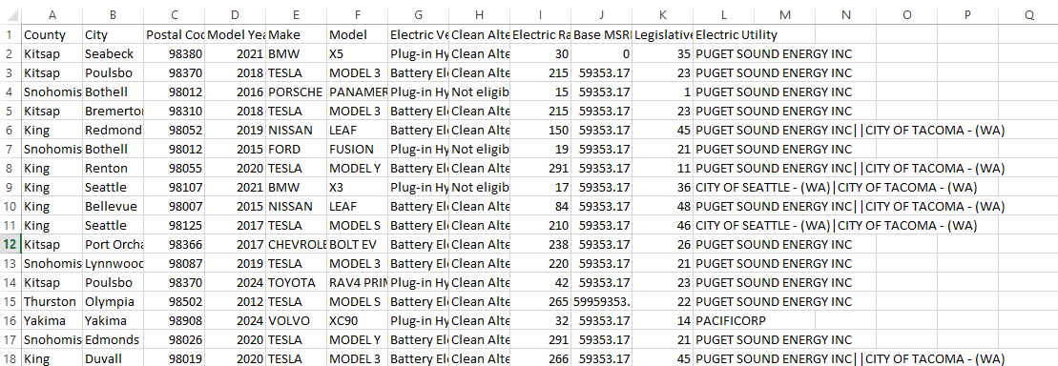Fig 1.

**# Step 2: Handling missing values**

# Fill missing values for 'Electric Range' and 'Base MSRP' with the median

ev_data['Electric Range'].fillna(ev_data['Electric Range'].median(), inplace=True)

ev_data['Base MSRP'].fillna(ev_data['Base MSRP'].median(), inplace=True)

****Fig 2.

**# Drop rows with missing 'County' and 'City'**

ev_data.dropna(subset=['County', 'City'], inplace=True)

**# Step 3: Convert 'Postal Code' to string and handle categorical columns**

ev_data['Postal Code'] = ev_data['Postal Code'].astype(str)

ev_data_encoded = pd.get_dummies(ev_data, columns=categorical_columns)

****Fig 3.

**# Step 4: Split 'Vehicle Location' into 'Latitude' and 'Longitude'**

ev_data[['Latitude', 'Longitude']] = ev_data['Vehicle Location'].str.extract(r'POINT \(([-\d\.]+) ([-\d\.]+)\)')

ev_data.drop(columns=['Vehicle Location'], inplace=True)

****Fig 4.

**# Step 5: Feature Engineering - Calculate 'Vehicle Age'**

ev_data['Vehicle Age'] = 2024 - ev_data['Model Year']

****Fig 5.

**# Step 6: Normalize 'Base MSRP' and 'Electric Range'**

scaler = MinMaxScaler()

ev_data[['Base MSRP', 'Electric Range']] = scaler.fit_transform(ev_data[['Base MSRP', 'Electric Range']])

****Fig 6.

**# Step 7: Remove specified columns and reduce dataset to 6000 entries**

ev_data.drop(columns=['DOL Vehicle ID', 'VIN (1-10)', '2020 Census Tract', 'Vehicle Age'], inplace=True)

ev_data = ev_data.head(6000)

print(ev_data.head())

****Fig 7.

**4. Visualizations**

**4.1 Part A: Pragati**

**Visualization 1**

**Measures Utilized:**

Measure 1: Make

Measure 2: Model Year

Measure 3: Electric Vehicle Type

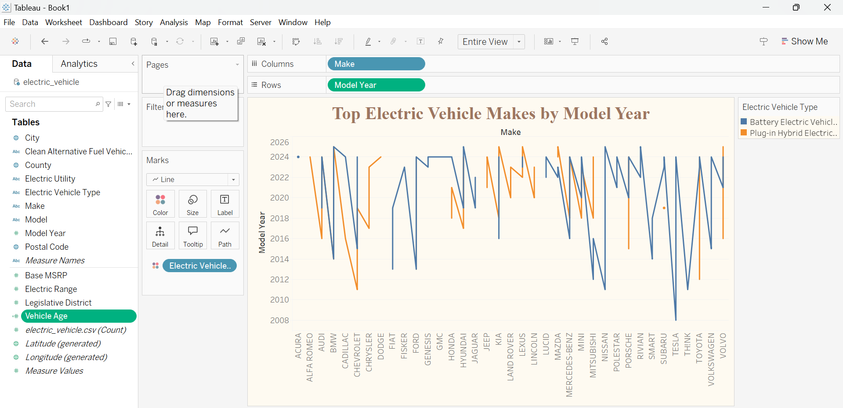Fig 8.

**Title**

* **Top Electric Vehicle Makes by Model Year**

**Purpose**

* To compare electric vehicle makes by model year, categorizing by electric vehicle type: Battery Electric Vehicles (BEVs) and Plug-in Hybrid Electric Vehicles (PHEVs). This helps in identifying trends over time across different vehicle makes.

**X-Axis (Columns)**

* **Make**: The different electric vehicle manufacturers, shown along the horizontal axis.

**Y-Axis (Rows)**

* **Model Year**: The model years of the electric vehicles, displayed vertically to show the time trend.

**Legend**

* **Electric Vehicle Type**: Differentiates between Battery Electric Vehicles (BEVs) and Plug-in Hybrid Electric Vehicles (PHEVs), with distinct colors for each type:
  + Blue for Battery Electric Vehicles (BEVs).
  + Orange for Plug-in Hybrid Electric Vehicles (PHEVs).

**Visualization 2**

**Measures Utilized:**

Measure 1: Make

Measure 2: Model Year

Measure 3: Electric Vehicle Type

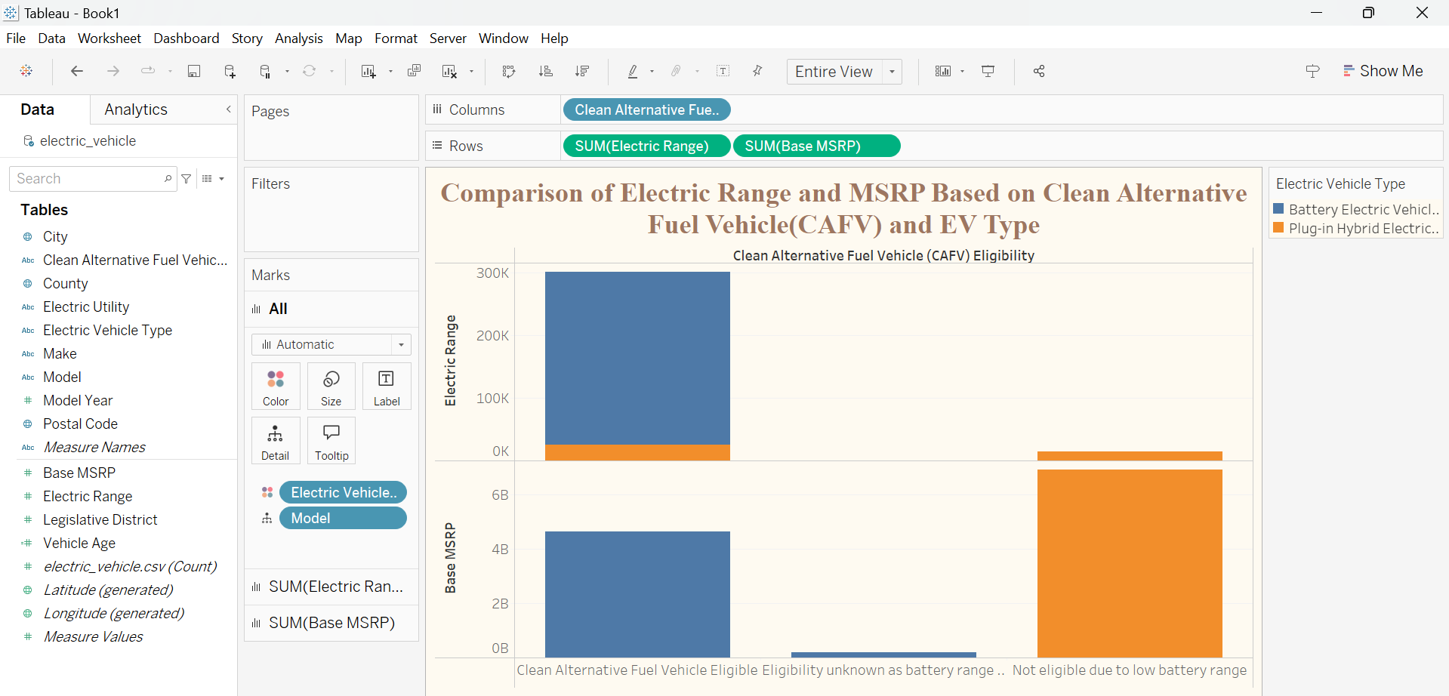

Fig 9.

**Title**

* **Comparison of Electric Range and MSRP based in Clean Electric Fuel Vehicle (CAFV) and EV Type**

**Purpose**

* To analyze how **Clean Alternative Fuel Vehicle (CAFV) eligibility** affects the **electric range** and **Manufacturer’s Suggested Retail Price (MSRP)** of electric vehicles, segmented by **Electric Vehicle (EV) type**—Battery Electric Vehicles (BEVs) and Plug-in Hybrid Electric Vehicles (PHEVs). This visualization provides insights into whether CAFV-eligible vehicles tend to have higher ranges or different price points, helping consumers, industry stakeholders, and policymakers understand the implications of CAFV eligibility on EV range and pricing.

**X-Axis (Columns)**

* **CAFV Eligibility**: Divides the data by vehicles that are eligible versus those that are not eligible for Clean Alternative Fuel Vehicle incentives.

**Y-Axis (Rows)**

* **Electric Range and MSRP**:
  + **Electric Range** (miles): Displays the electric range of each vehicle, showing how far they can travel on a full charge.
  + **MSRP** ($): Represents the Manufacturer’s Suggested Retail Price, showing the cost distribution for vehicles with different ranges.

**Legend**

* **EV Type**: Distinguishes between Battery Electric Vehicles (BEVs) and Plug-in Hybrid Electric Vehicles (PHEVs) using different colors or symbols:
  + Blue for BEVs
  + Orange for PHEVs

**Visualization 3**

**Measures Utilized:**

Measure 1: Make

Measure 2: Model Year

Measure 3: Electric Vehicle Type

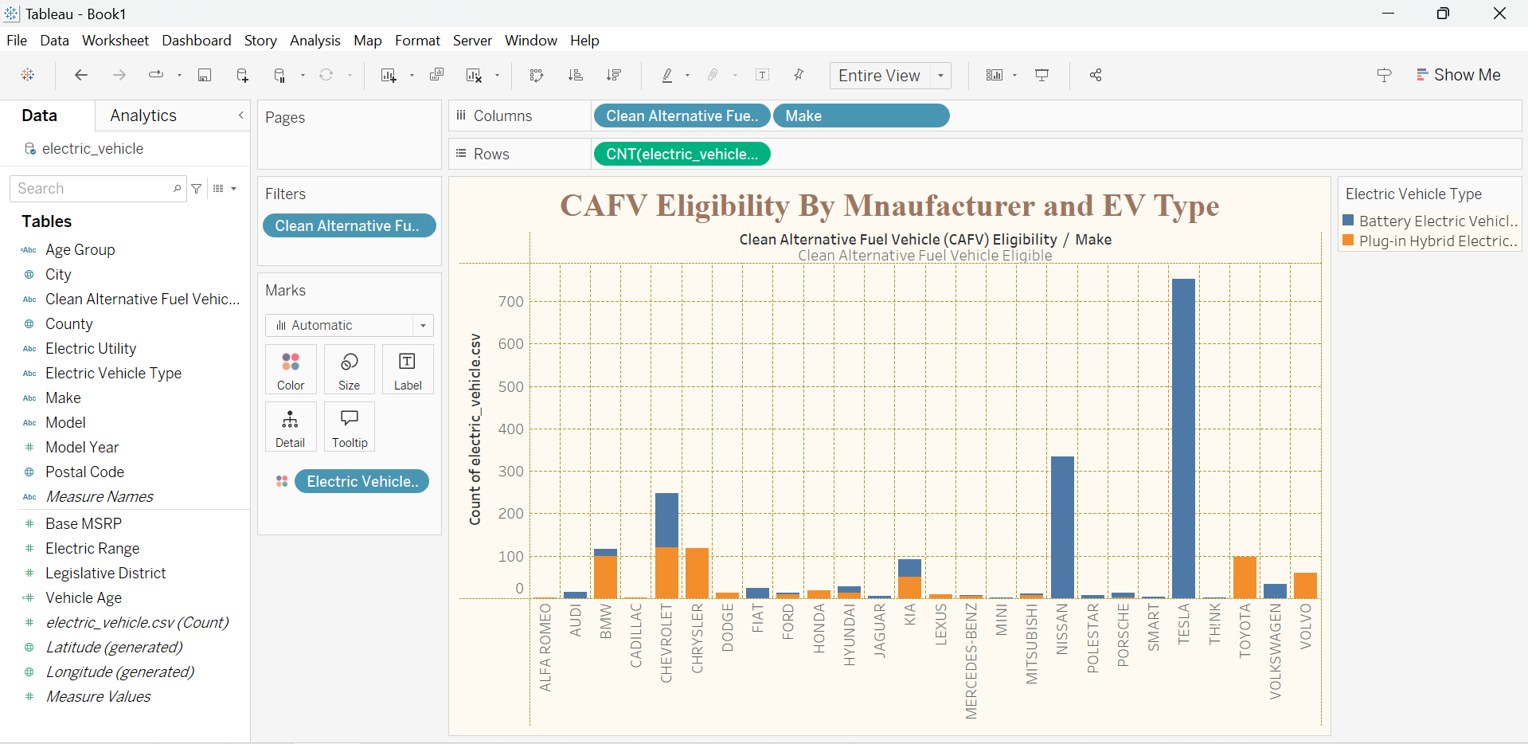

Fig 10.

**Title**

* **CAFV Eligibility by Manufacturer and EV Type**

**Purpose**

* To explore the distribution of **Clean Alternative Fuel Vehicle (CAFV) eligibility** across different **manufacturers** and **electric vehicle (EV) types**. This visualization provides insight into which manufacturers have the most CAFV-eligible vehicles and how these vehicles are distributed between Battery Electric Vehicles (BEVs) and Plug-in Hybrid Electric Vehicles (PHEVs). This helps in identifying leading manufacturers in the CAFV-eligible EV market.

**X-Axis (Columns)**

* **CAFV Eligibility**: Divides the data by vehicles that are eligible versus those that are not eligible for Clean Alternative Fuel Vehicle incentives.
* **Make**: The different electric vehicle manufacturers, shown along the horizontal axis.

**Y-Axis (Rows)**

* **Count of Electric Vehicles:** The number of electric vehicles in Washington State

**Filter**

* **CAFV Eligibility:** We have only kept those vehicles that are eligible.

**Legend**

* **EV Type**: Distinguishes between Battery Electric Vehicles (BEVs) and Plug-in Hybrid Electric Vehicles (PHEVs) using different colors or symbols:
  + Blue for BEVs
  + Orange for PHEVs

**4.2 Part B: Shreyaa**

**Visualization 4**

**Measures Utilized:**

Measure 1: City

Measure 2: Count of electric vehicles

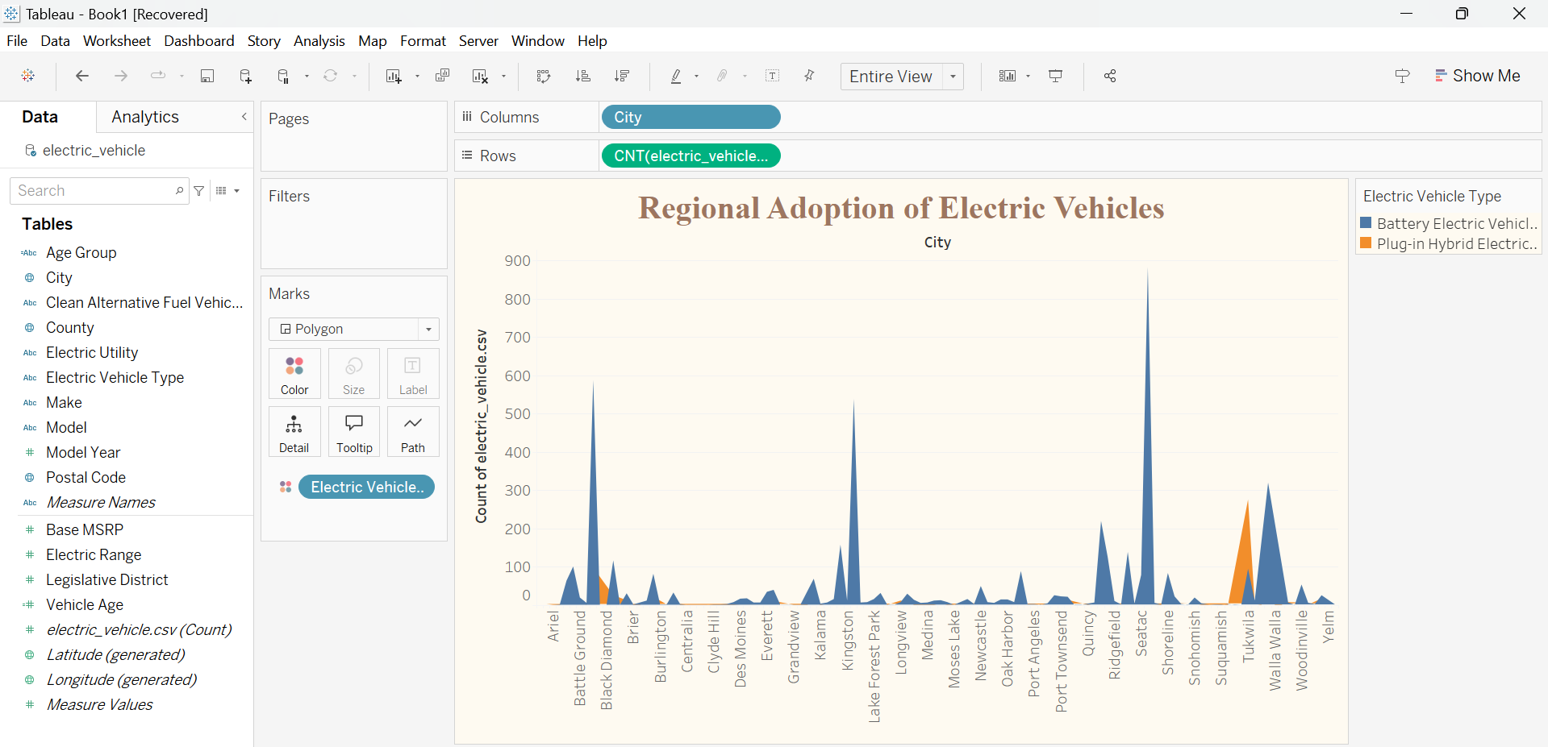Fig 11.

**Title**

* **Regional Adoption of Electric Vehicles**

**Purpose**

* To explore which city has adopted which type of electric vehicles and their count.

**X-Axis (Columns)**

* **City**: City in the state of Washington in the USA.

**Y-Axis (Rows)**

* **Count of Electric Vehicles:** The number of electric vehicles in Washington State

**Legend**

* **EV Type**: Distinguishes between Battery Electric Vehicles (BEVs) and Plug-in Hybrid Electric Vehicles (PHEVs) using different colors or symbols:
  + Blue for BEVs
  + Orange for PHEVs

**Visualization 5**

**Measures Utilized:**

Measure 1: Model Year

Measure 2: Count of Electric Vehicles

Measure 3: Make

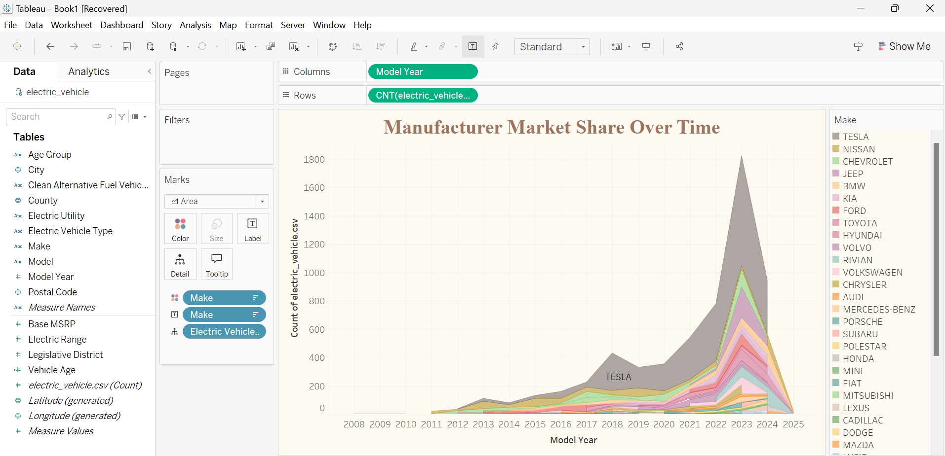Fig 12.

**Title**

* **Manufacturer Market Share Over Time**

**Purpose**

* To explore the market share of different manufacturers over time based count of electric vehicles and model year.

**X-Axis (Columns)**

* **Model Year**: The model years of the electric vehicles, displayed vertically to show the time trend.

**Y-Axis (Rows)**

* **Count of Electric Vehicles:** The number of electric vehicles in Washington State

**Legend**

* **Make**: Distinguishes between different manufacturers of vehicles using different colors.

**Visualization 6**

**Measures Utilized:**

Measure 1: Model Year

Measure 2: Count of electric vehicles

Measure 3: Electric Vehicle Type

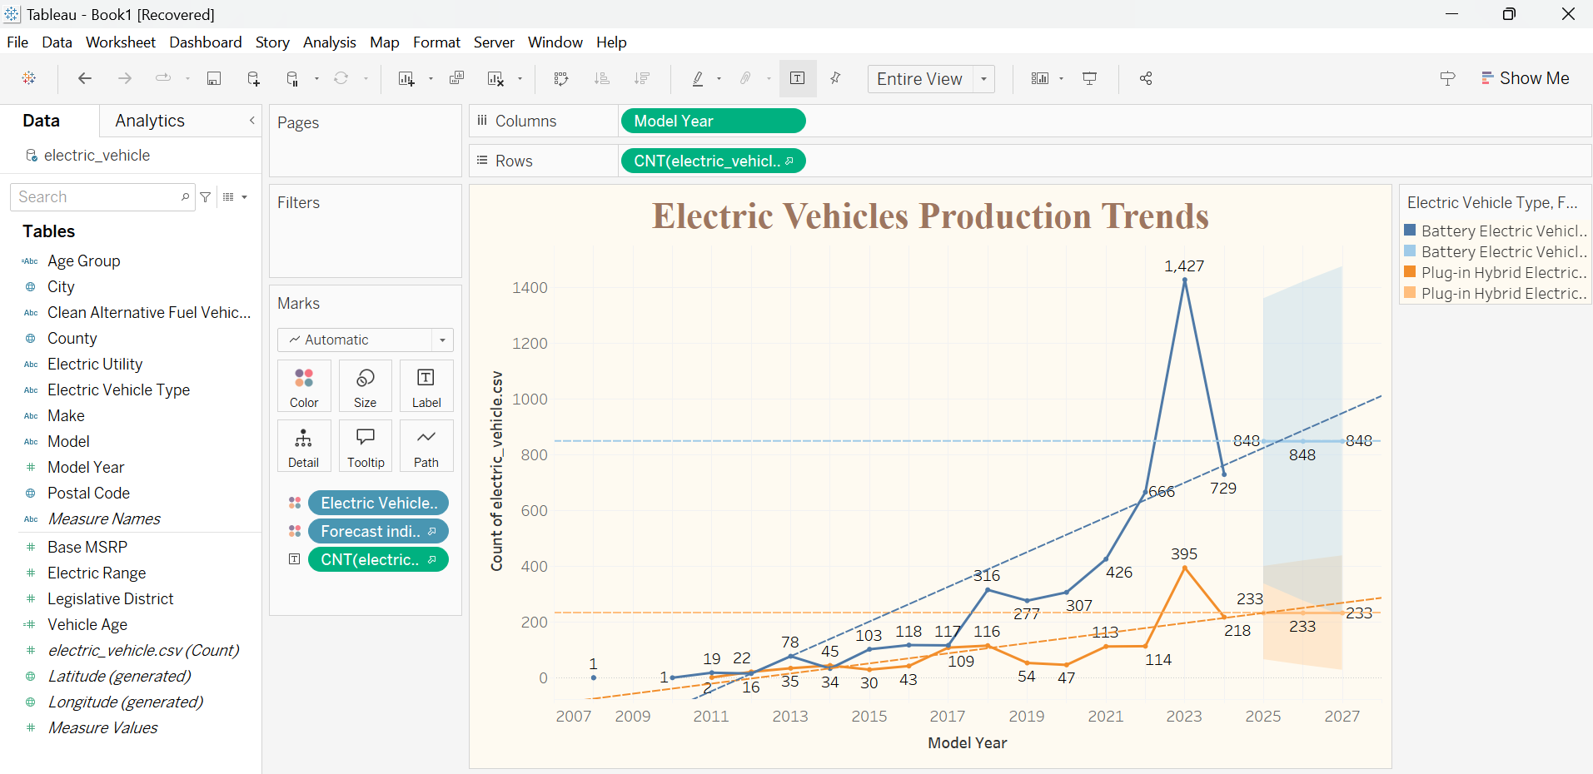Fig 13.

**Title**

* **Electric Vehicles Production Trends**

**Purpose**

* To analyze and forecast the **production trends** of electric vehicles (EVs) over time, segmented by **EV type**—Battery Electric Vehicles (BEVs) and Plug-in Hybrid Electric Vehicles (PHEVs). This visualization helps in understanding historical growth patterns in EV production, identifying peak production years, and providing an outlook on future production trends.

**X-Axis (Columns)**

* **Model Year**: Displays the year of production, showing the progression of EV production from 2007 through 2027, including historical data and forecasted values.

**Y-Axis (Rows)**

* **Count of Electric Vehicles (CNT(electric_vehicle.csv))**: Represents the total count of electric vehicles produced, allowing for a comparison of production volume across different years.

**Legend**

* **Electric Vehicle Type and Forecast Indicator**: Differentiates between Battery Electric Vehicles (BEVs) and Plug-in Hybrid Electric Vehicles (PHEVs) as well as historical and forecasted data:
  + Solid lines represent historical production counts.
  + Dotted lines represent forecasted production counts for the upcoming years.
  + Blue for BEVs and orange for PHEVs

**3.3 Part C: Riya**

**Visualization 7**

**Measures Utilized:**

Measure 1: Electric Utility

Measure 2: Average Electric Range

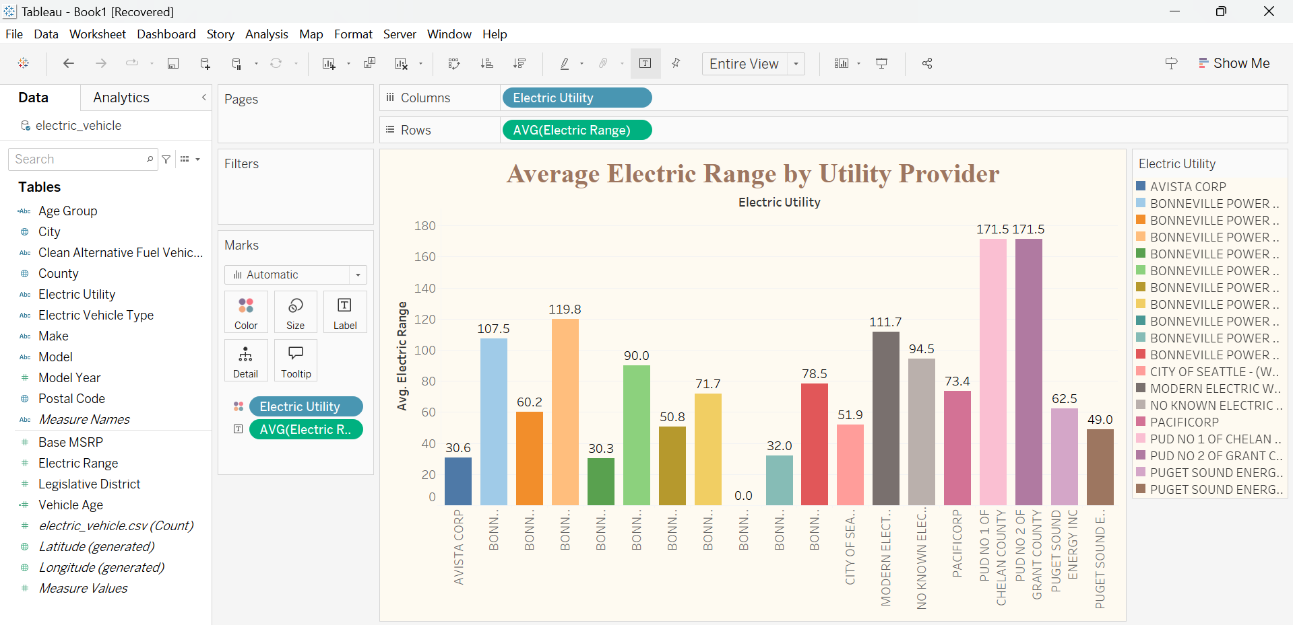Fig 14.

**Title**

* **Average Electric Range by Utility Provider**

**Purpose**

* To explore average electric range provided by different utility providers based on Counties and Cities in the State of Washington to figure out which utility provides the highest electric range.

**X-Axis (Columns)**

* **Electric Utility:** The different electric vehicle manufacturers, shown along the horizontal axis.

**Y-Axis (Rows)**

* **Count of Electric Vehicles:** The number of electric vehicles in Washington State

**Legend**

* **Electric Utility**: Distinguishes between different utility providers of vehicles using different colors.

**Visualization 8**

**Measures Utilized:**

Measure 1: Age Group

Measure 2: Electric Range

Measure 3: Make

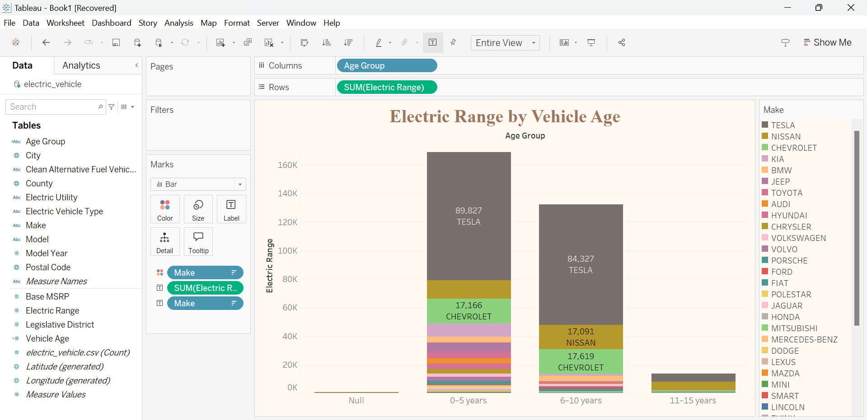

Fig 15.

**Title**

* **Electric Range by Vehicle Age**

**Purpose**

* To explore which age group of vehicles provides the best electric range and by which manufacturer.

**X-Axis (Columns)**

* **Make**: The different electric vehicle manufacturers, shown along the horizontal axis.

**Y-Axis (Rows)**

* **Count of Electric Vehicles:** The number of electric vehicles in Washington State

**Legend**

* **Make**: Distinguishes between different manufacturers of vehicles using different colors.

**5. Dashboard & Insights**

**5.1 Dashboard 1**

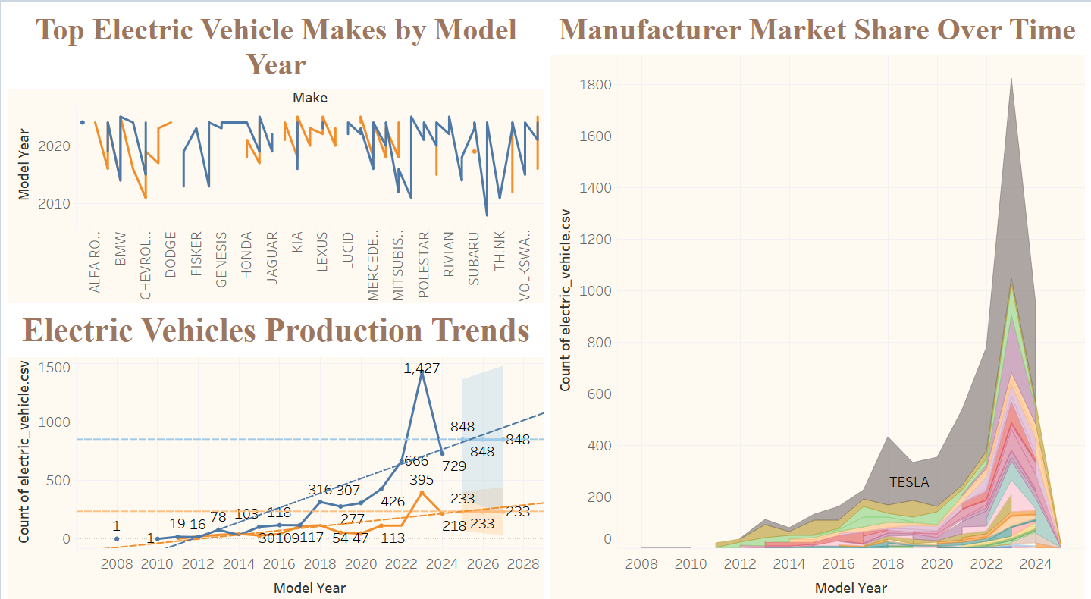Fig 16.

**Insights from this dashboard**

1. **Rapid Growth Post-2018**: The EV market has experienced rapid growth in production, particularly after 2018, driven largely by Tesla's significant output.
2. **Diverse Manufacturer Involvement**: While Tesla holds a major portion of the market, other manufacturers are consistently contributing, suggesting a competitive and growing market with new entrants and existing players expanding their production.
3. **Tesla’s Market Leadership**: Tesla’s pronounced lead reinforces its role as the dominant force in the EV industry, emphasizing the brand’s impact on shaping market trends and pushing technological advancements.
4. **Competitor Presence**: Despite Tesla's stronghold, other manufacturers such as Volkswagen, Mercedes, and emerging brands are maintaining consistent production levels, indicating healthy competition and potential shifts in future market share.
5. **Increased Model Diversity**: The growth in the number of unique vehicle models post-2018 demonstrates a broadening selection for consumers, signaling that manufacturers are diversifying their offerings to meet different market needs.

**5.2 Dashboard 2**

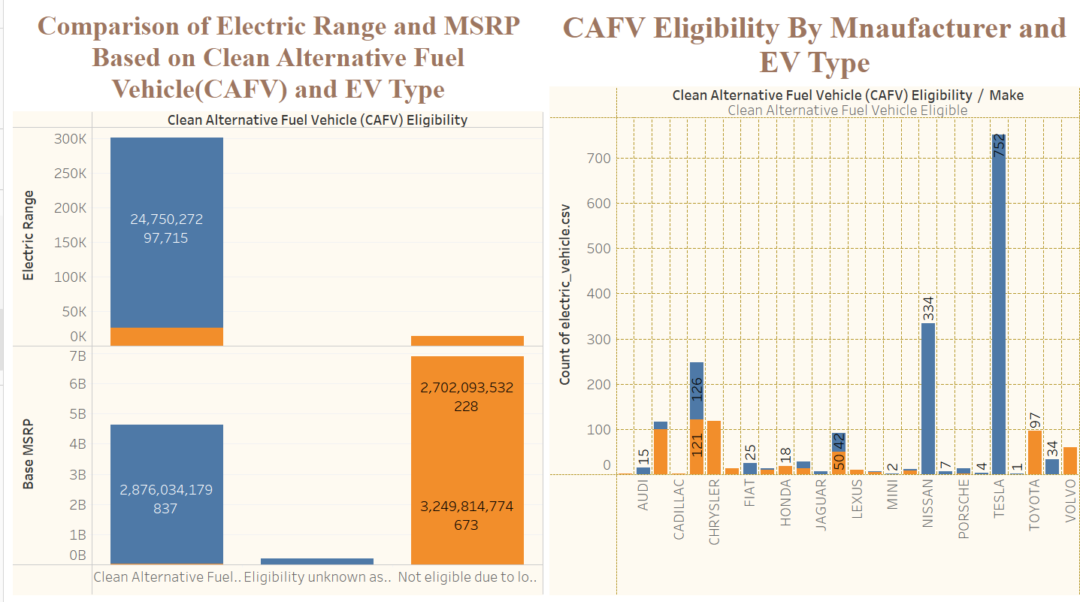Fig 17.

**Insights from this dashboard**

1. **Policy Impact**: The data underscores how government incentives and policies impact the electric vehicle market, with more expensive, higher-performance EVs being eligible for CAFV credits.
2. **Market Trends**: The large number of eligible vehicles by specific manufacturers suggests they are leading the market in aligning with clean energy standards.
3. **Manufacturer Strategy**: Tesla's leadership in CAFV-eligible vehicles reinforces its strategy of producing high-range, premium electric vehicles that meet regulatory requirements for clean energy incentives.
4. **Economic Influence on Consumer Choice**: The higher MSRP for CAFV-eligible vehicles may indicate that consumers willing to invest in higher-priced EVs are more inclined toward models that qualify for clean fuel incentives. This suggests a market trend where premium, high-performance vehicles align better with government regulations for sustainability.
5. **Manufacturer Positioning and Strategy**: The data highlights a gap between manufacturers in terms of eligibility. Companies like Chrysler and Cadillac, which show lower CAFV eligibility, might need to re-strategize their vehicle offerings to meet clean energy standards and compete with leaders like Tesla and Toyota.

**5.3 Dashboard 3**

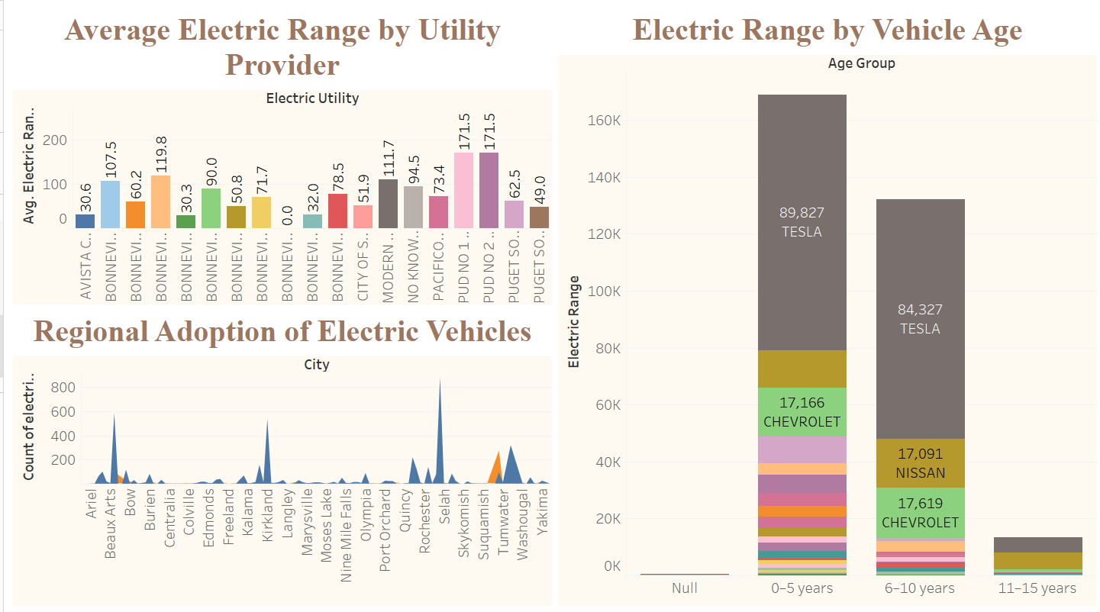

Fig 18.

**Insights from this dashboard**

1. Tesla vehicles dominate the electric range for newer models, particularly in the 0–5 years age group. This trend suggests that Tesla's market presence and technology lead to higher range capabilities, making it the preferred choice for long-distance EV travel.
2. The range differences between newer (0–5 years) and older EVs (6–10 years, 11–15 years) are pronounced, highlighting improvements in battery capacity, energy efficiency, and overall vehicle design. This indicates that technological advancements have made newer EVs much more practical for extended travel.
3. Seattle has the highest count of EVs, with other nearby cities like Bellevue, Kirkland, and Redmond also showing significant adoption. This suggests that the region may have supportive policies, charging infrastructure, or a consumer base that favors eco-friendly options, all contributing to popularity of EVs.
4. The average electric range provided by different utilities varies considerably, from about 30 miles to over 170 miles. This may indicate differing levels of investment in EV-related infrastructure, variable incentives, or distinct regional needs and usage patterns among customers.

Bottom of Form

**6. Summary**

The visualizations provide a comprehensive understanding of the **electric vehicle market**, revealing critical insights into production trends, regional adoption, and the relationship between vehicle pricing and performance. Key findings include **Tesla’s dominance** in electric vehicle production, particularly in the **Battery Electric Vehicle (BEV)** segment, and the growing concentration of EVs in urban centers like **Seattle**. The clustering analysis highlights clear segmentation within the market, distinguishing between budget-friendly, mid-range, and premium vehicles based on price and electric range. Additionally, the forecasting analysis suggests continued growth in BEV production, with plug-in hybrids showing a slower trajectory.

Regional data underscores the importance of infrastructure and government incentives in fostering higher EV adoption rates, with Clean Alternative Fuel Vehicle (CAFV) eligibility playing a significant role in driving consumer interest. Ultimately, the analysis reflects the broader trend toward **fully electric vehicles**, with improvements in electric range and affordability contributing to their increasing popularity. The findings suggest that continued investment in infrastructure, incentives, and technological advancements will further accelerate the shift towards a more sustainable transportation future.

**7. References**

1. [**https://catalog.data.gov/dataset/electric-vehicle-population-data**](https://catalog.data.gov/dataset/electric-vehicle-population-data)

### [**https://www.tableau.com**](https://www.tableau.com)

### [**https://www.tableau.com/learn/training**](https://www.tableau.com/learn/training)

### [**https://public.tableau.com/en-us/s/**](https://public.tableau.com/en-us/s/)

### [**https://help.tableau.com/current/pro/desktop/en-us/forecasting.htm**](https://help.tableau.com/current/pro/desktop/en-us/forecasting.htm)

### [**https://help.tableau.com/current/pro/desktop/en-us/calculations_calculatedfields_create.htm**](https://help.tableau.com/current/pro/desktop/en-us/calculations_calculatedfields_create.htm)

### [**https://www.tableau.com/developer**](https://www.tableau.com/developer)

### [**https://www.tableau.com/learn/tutorials/on-demand/calculated-fields**](https://www.tableau.com/learn/tutorials/on-demand/calculated-fields)